**CIS 572 Object Oriented System Design**

**Backward Tracing**

**Member Payment**

Submitted to:  Mr. Thomas Steiner

Submitted by : Mohanapriya Kottan Rajaraman

UMID 54887398

**Table of Contents**

INTERFACE 3

CRC CARD 3

STATE DIAGRAM 4

DATA FLOW DIAGRAM (DFD) 4

CLASS DIAGRAM 5

SEQUENCE DIAGRAM 5

COMMUNICATION DIAGRAM 6

BUILD ERD 6

USE CASE DIAGRAM 6

USE CASE FLOW 7

# INTERFACE

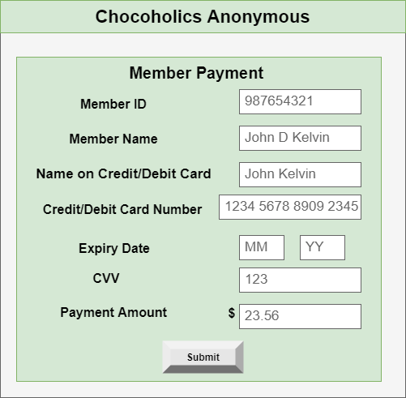

# CRC CARD

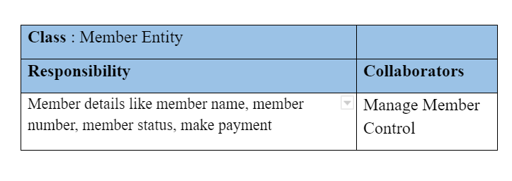

# STATE DIAGRAM

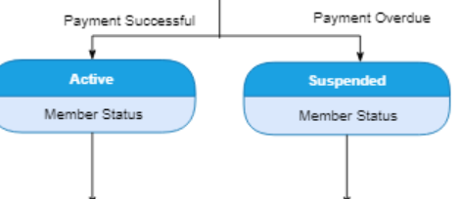

# 

# DATA FLOW DIAGRAM (DFD)

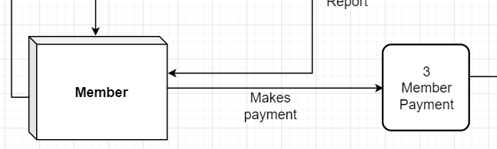

# CLASS DIAGRAM

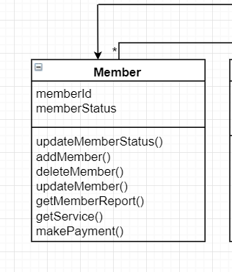

# SEQUENCE DIAGRAM

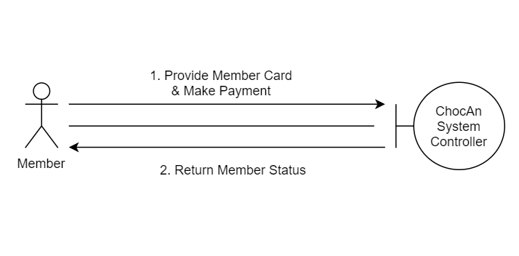

# COMMUNICATION DIAGRAM



# BUILD ERD

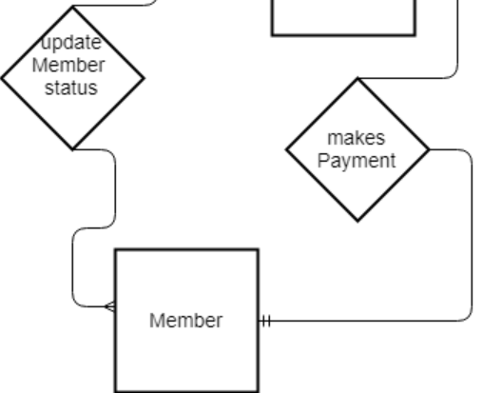

# USE CASE DIAGRAM

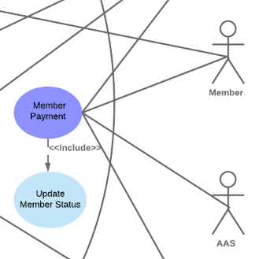

# USE CASE FLOW



## 

# 

# 

# 

# 

# 

# 